Fizz Frisk Design Brief

Version 1.0

By Corey, Cody and Jamie

Contents

Overview 1

Gameplay 2

Core Mechanics 3

Conveyor Belt 3

X-ray device 3

Cans 3

Lives 3

Score 4

Level Overview 5

SFX Asset List 6

# Overview

Fizz Frisk is a simple, casual 2D game where the player assumes the role of a new factory worker at the Atomic Elixirs canning facility. They must ensure that no contaminated drinks make it through the conveyor belt and are sent out for shipping.

# Gameplay

In Fizz Frisk the player will need to prevent contaminated drinks from making it through the conveyor belt, to do this they can remove contaminated cans from the conveyor belt by clicking on them. To check to see if a can is contaminated the player will use an X-ray device to scan the inside of the cans and ensure they’re not contaminated.

In Fizz Frisk the player has two sets of three ‘lives’ being that they can only let a maximum of three contaminated cans pass through or remove three safe cans before it is game over. There will be no time limit in Fizz Frisk, the only two conditions for losing are if the player allows 3 contaminated cans to slip through or they remove 3 safe cans. These 2 conditions are separate from one another, meaning if the player lets 2 contaminated cans through and removes 1 safe can, this will not result in losing. Either 3 safe cans must be removed, or 3 contaminated cans must get through.

The player has a score counter showing how many cans they have correctly sent through to be packaged.

# Core Mechanics

## Conveyor Belt

* The conveyor belt moves cans along at a rate of 1 can every 2 seconds.
* The conveyor belt shows up to 5 cans at a time.
* Once a can is moved off screen it is de-spawned and a new can is spawned at the beginning of the conveyor belt.

## X-ray device

* The X-ray device is an interactable object that can be turned on and moved across the screen by the player.
* It is used by the player to scan the interior of the cans to inspect them.

## Cans

* In Fizz Frisk the Atomic Elixir™ soft drink serves as the core of the game.
* Cans spawn off-screen at the beginning of the conveyor belt and move across until off screen. Once off-screen they de-spawn and a new can is spawned at the beginning.
* Cans can be dragged off the conveyor belt and trashed by the player.
* Safe cans appear empty when scanned by the X-ray device.
* Contaminated cans contain foreign objects when scanned by the X-ray device.

## Lives

* The player has two life pools, each one containing 3 lives.
* One pool of lives is affected by contaminated cans, for each contaminated can that is allowed through the player will lose one life from this pool.
* The other pool of lives is affected by safe cans, for each safe can that is erroneously trashed by the player a life from this pool is lost.
* Once the player is out of lives for either contaminated cans or safe cans, the game is over.

## Score

* The player’s score is tracked by a counter in the top centre of the screen.
* The player can increase their score by allowing safe cans through the conveyor belt.

# Level Overview

Fizz Frisk contains a single level situated within a canning factory. This factory contains industrial machinery such as conveyor belts, pipes, steam machines and warning lights and signs. The factory is well lit with industrial lighting, making distant machinery visible. The industrial setting of the level will inform our sound design choices, such as the ambient sound and noises heard in the game.

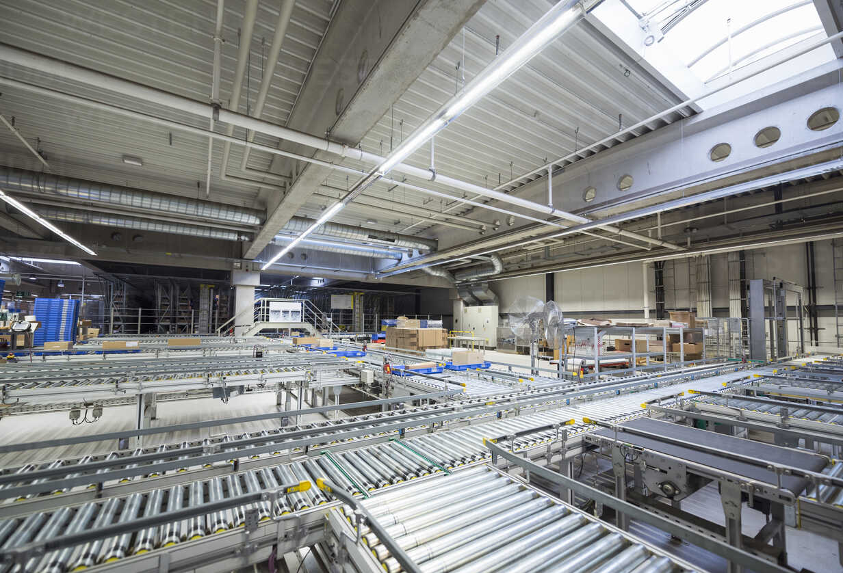

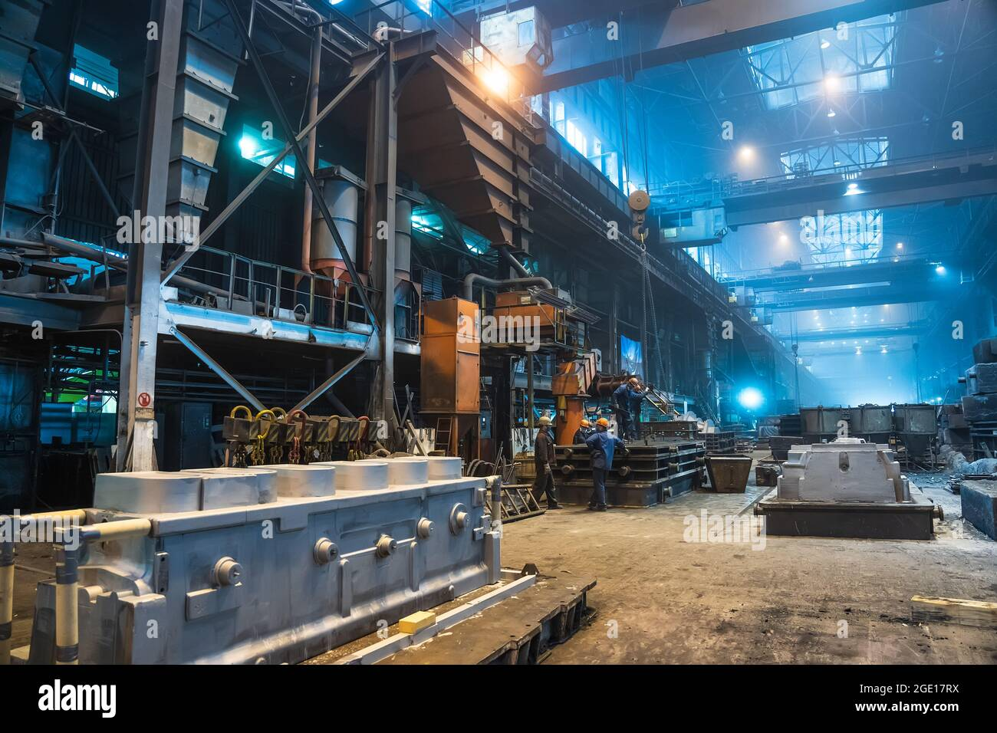

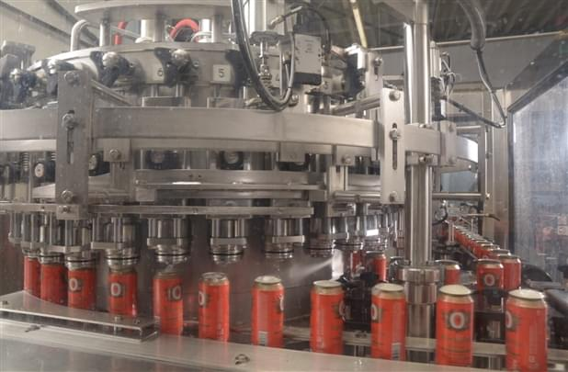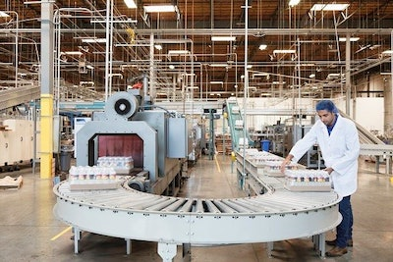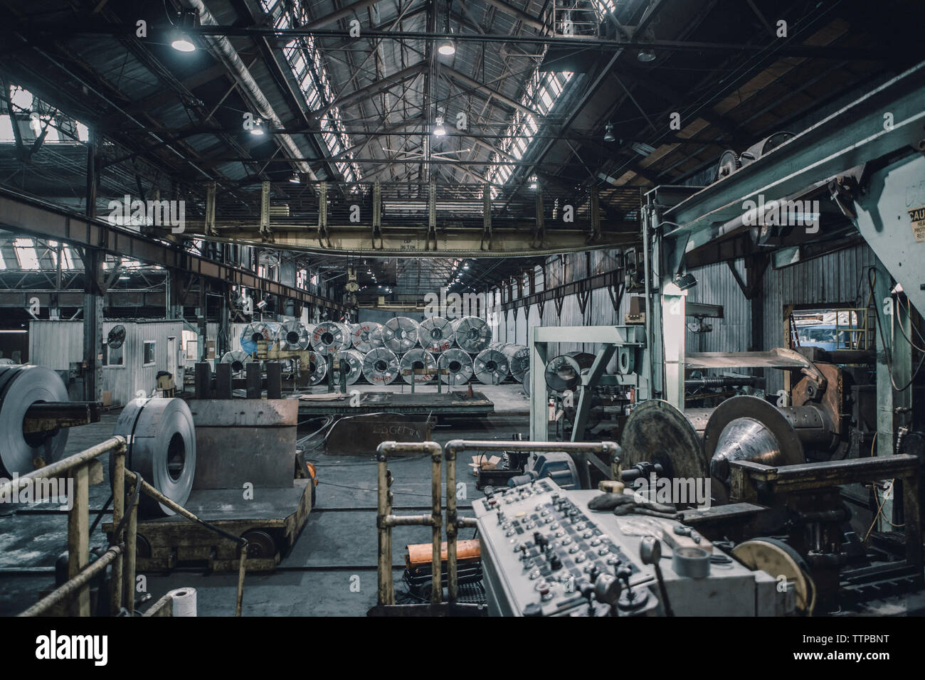

# SFX Asset List

# Risk Assessment & Acknowledgement

Our Sound Design team have opted for low sample size and bit rate SFX and music for the project. Resultingly, these sounds may be sharp, shrill, and may cause the listener discomfort when played at higher volumes. Accordingly, we will manage and adjust the amplitudes of each sound and music piece during editing to minimize the risk of auditory damage for both our development team and our audience. Another precaution for our team is that we will ensure they take regular breaks from listening to audio files when working on the project, and that they will be using high quality, comfortable headphones.

Another identified risk is that several of our project’s sounds will be custom created remotely, increasing the chance of data loss and / or incompatible file porting. To minimize this risk, our development team will be utilizing source control via GitHub to ensure that retrievable copies and backlogged data is always accessible by the team, wherever their location.